DIA Microsoft 365 (M365) Web Apps Guide
Contents
Requirements 2
DoD Certificates Installation Guide for Windows OS 2
Install DoD Root Certificates 2
DoD Root Certificate Troubleshooting: 7
Administrator Rights 7
Plan A 7
Plan B 9
DoD Certificates Installation Guide for Mac OS 11
Install DoD Root Certificates 11
Microsoft 365 (M365) Web-based Applications 14

Requirements
- Home computer
- Common Access Card (CAC)
- CAC reader
- Microsoft Edge or Google Chrome browser

User Note: If you have previously installed DoD Root Certificates (Windows) on your home computer, you can skip ahead to the Microsoft 365 (M365) and/or Azure Virtual Desktop (AVD) sections of this user guide.

DoD Certificates Installation Guide for Windows OS
See the below instructions to complete the install of the DOD PKE InstallRoot application. DoD certificates must be installed prior to accessing CAC-enabled DIA sites from a remote location.

Note: If your device is running Windows 10/11 on a 64-bit ARM CPU you will need to use the 32-bit installers. The 64-bit installer is not optimized for the ARM chipset.

Install DoD Root Certificates
- Navigate to Tools and Configuration Files on the DoD Cyber Exchange (Public) site (https://public.cyber.mil/pki-pke/tools-configuration-files/).

- Choose one of the following three Installer options, based on the age of your home computer and access to administrative privileges:
  - InstallRoot 5.5 NIPR 32-bit Windows Installer (Preferred): Older computers/requires administrator rights.
  - InstallRoot 5.5 NIPR 64-bit Windows Installer (Preferred): Modern computers/requires administrator rights.
  - InstallRoot 5.5 NIPR Non-Administrator 32-bit Windows Installer: Older computers/does not require administrator rights, but may require helpdesk support/troubleshooting depending on computer set up.

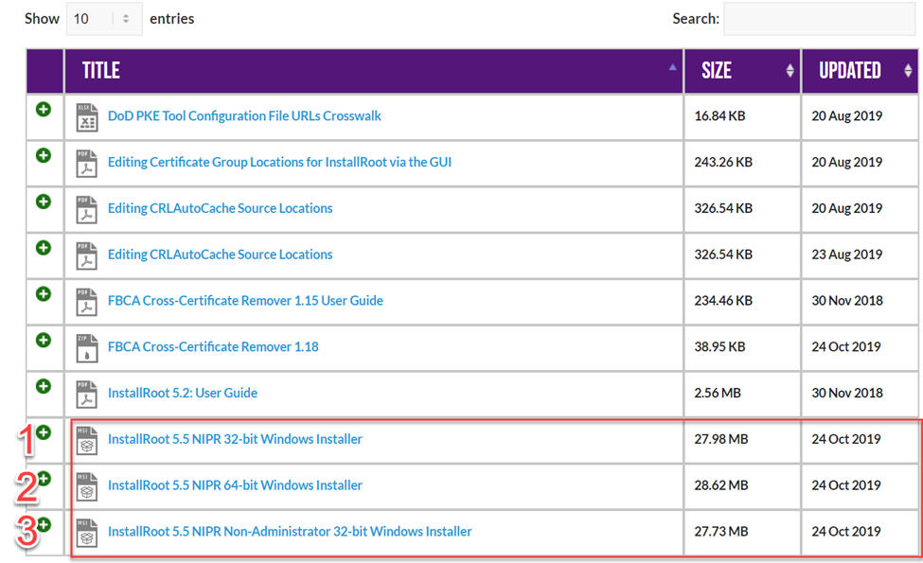
- Click on your preferred file to download it to your local computer, and then launch Installer by clicking ‘Open’ or ‘Save.’ Note: The first image below is an example of Installer (#2) downloaded from the Edge browser. The second image below is an example of Installer (#2) downloaded from the Chrome browser.

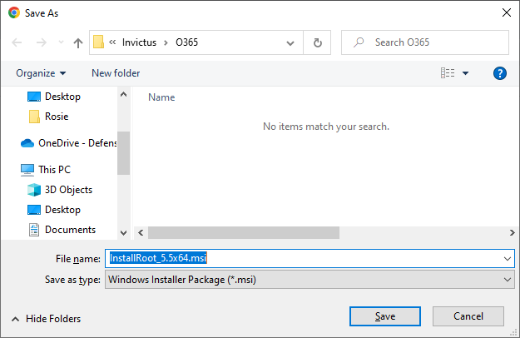

- Click ‘Next’ when prompted at the InstallRoot Setup Wizard.

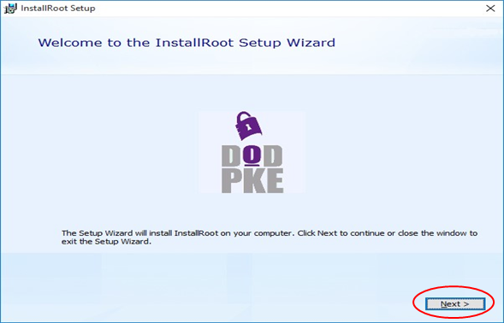

- Choose the defaulted file location (or select another location by clicking ‘Browse’) for file installation, then click ‘Next.’
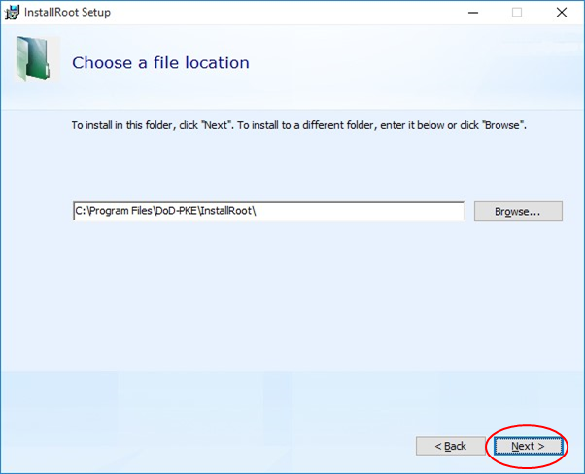

- Upon the ‘InstallRoot Features’ prompt, leave the default options checked and click ‘Next.’ Note: The non-administrator install option will not include the ‘Windows Service’ feature.

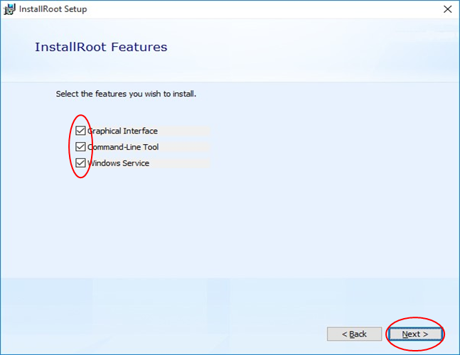

- After the installation completes, click ‘Run InstallRoot.’
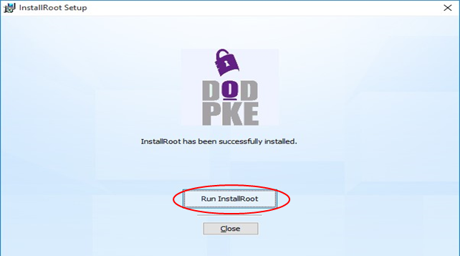

- If the following window appears, select ‘Yes.’

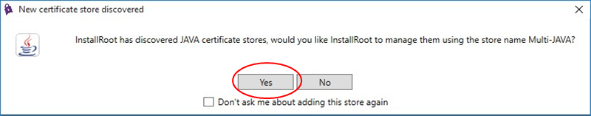

- Verify that the desired certificate store is targeted, and then click ‘Next’ to close the window.

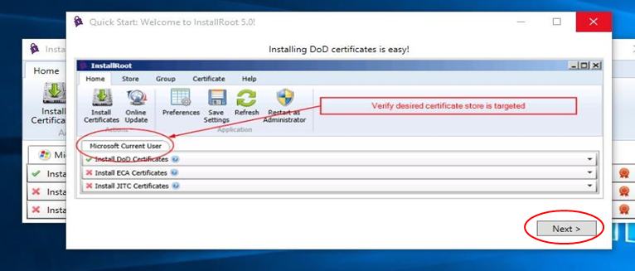

- Click ‘Restart as Administrator.’ Click ‘Yes’ to all subsequent pop-ups asking for granting application permissions to make changes. Note: If you already ran the InstallRoot application as an Administrator, you will not see the ‘Restart as Administrator’ option.
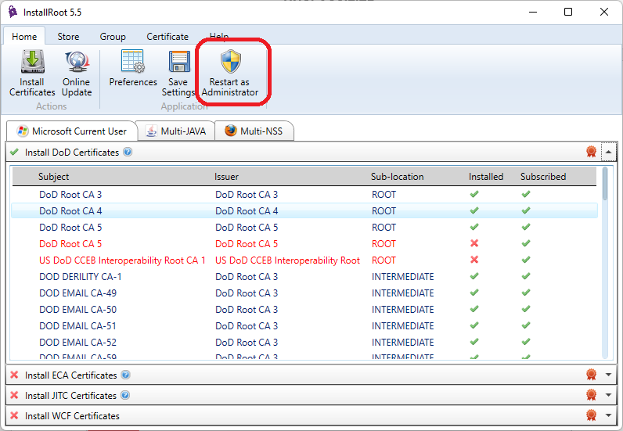

- Click ‘Install Certificates.’ Once you click the drop-down next to the red ribbon, you should see a green ‘check’ mark next to the respective certificates (DoD Root CA 3, 4, 5), with a red ‘X’ mark next to a second DoD Root CA 5 certificate. Note: If your PKE tool (InstallRoot 5.5) does not appear like the screen below, start over from Step 1.

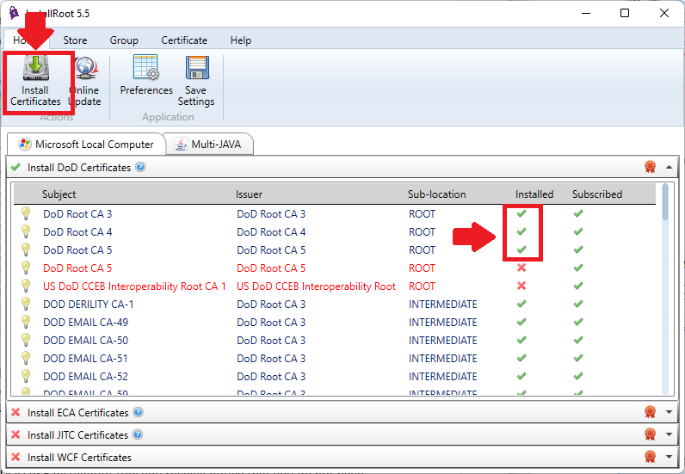

DoD Root Certificate Troubleshooting:

Administrator Rights
If during the installation/execution of the DoD PKE InstallRoot tool you receive notice that you do not have the proper administrative rights, but you are logged in as Administrator, your firewall may be blocking the action. Attempt the following troubleshooting steps:
- Attempt to temporarily turn off your firewall while installing the DoD PKE Tool. Download the correct DOD PKE application for your device.
- Use the 32-bit non-Admin installer. This action should install the certificates for the local user but may not fix issues with VPN and firewall blocking.
- Run the ‘Windows Command Prompt’ as an administrator and then launch InstallRoot from the command line.

Plan A
  - Download the correct InstallRoot version (32-bit or 64-bit) that requires Administrator privileges for your operating system.
  - Open File Explorer.

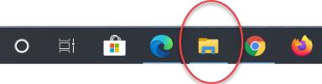

  - Go to the download folder where InstallRoot is located. (i.e., C:\Users\Jim\Downloads).

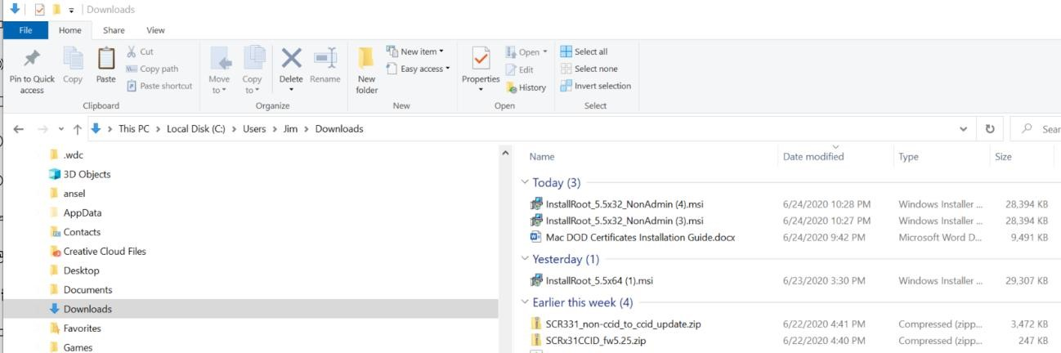

- Copy the file location into the Address Bar (i.e., C:\Users\Jim\Downloads)

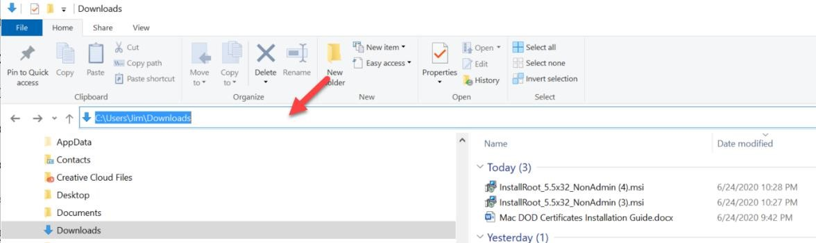

- If extensions are not available on the File name, click on the ‘View’ tab, then click on ‘File Name Extensions.’ Choose extension ‘.msi’ for ‘Microsoft Installer.’
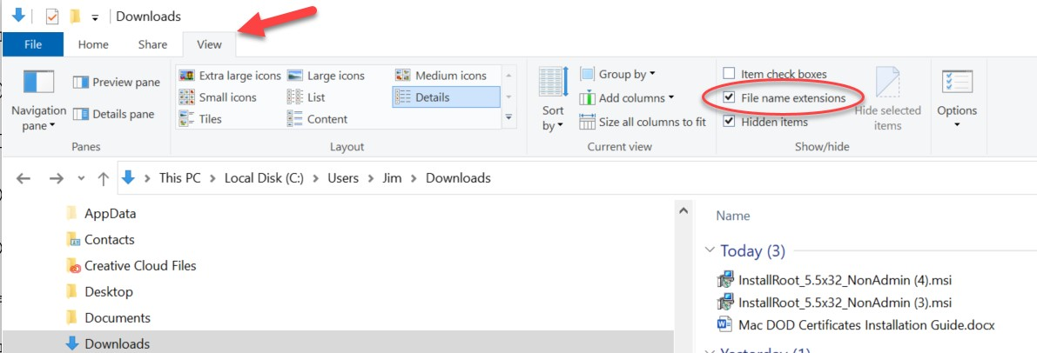

- Click on the ‘Windows Start icon, then type ‘CMD’ in the search field, and then click ‘Run as administrator.’

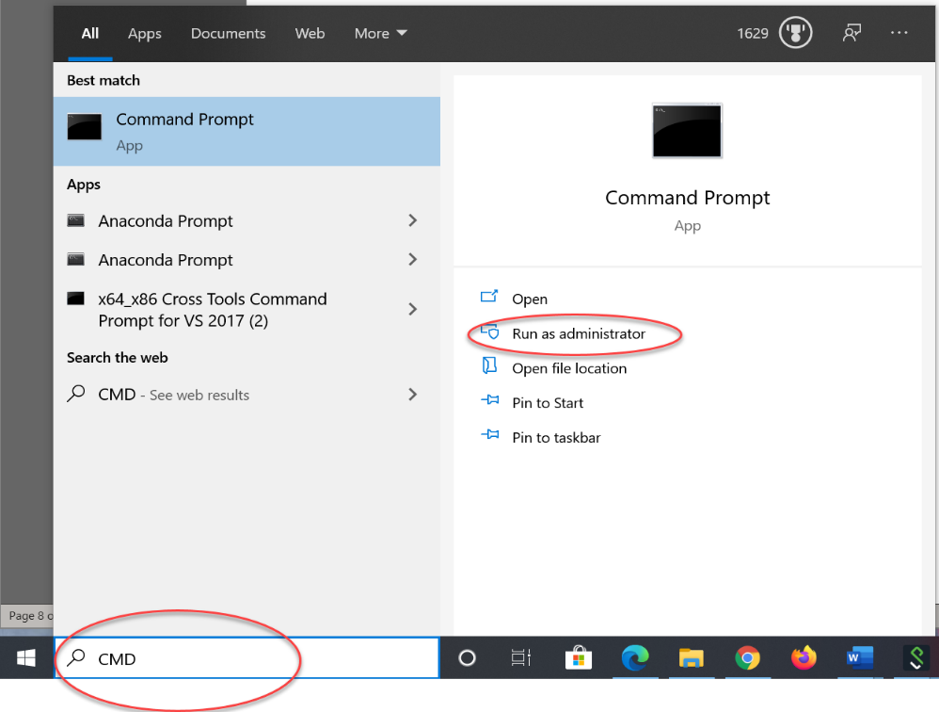

- Click ‘Yes’ to the Windows message requesting the application make changes to your device.
- In the CMD Prompt window, type ‘CD’ and the file location (i.e., “CD C:\Users\Jim\Downloads”). Click the ‘enter’ key on your keyboard to navigate to the Download directory.

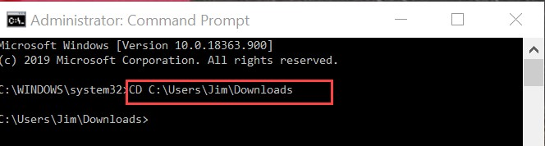

- Type in the full file name of the Installer file (i.e., “InstallRoot_5.5x64.msi” and then hit the ‘enter’ key on your keyboard. The InstallRoot will run; from this point, follow the instructions above beginning with Step 3.

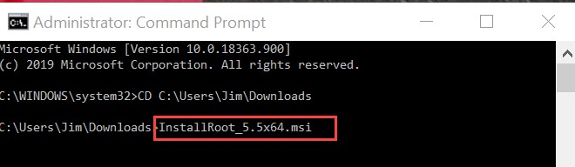

Plan B
If when switching the application to Administrator mode, you receive a message that you do not have permissions or the application is being blocked for your protection, you will then need to run the InstallRoot application through the Command Prompt.

- In the Administrator Command prompt type “CD C:\Program Files\DoD-PKE\InstallRoot” and then hit the ‘enter’ key on your keyboard.

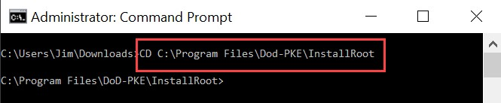

- Type “InstallRootUI.exe” and then hit the ‘enter’ key on your keyboard. The InstallRoot application will then start in Administrator mode.

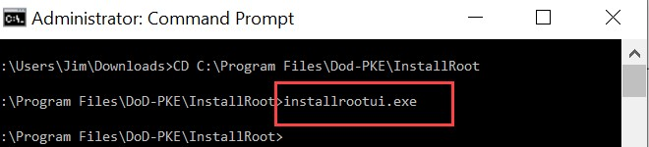

- Click on ‘Online Update.’ Once the application provides a status of TAMP, click ‘Install Certificates.’ The DoD Root Certificate should now be installed.

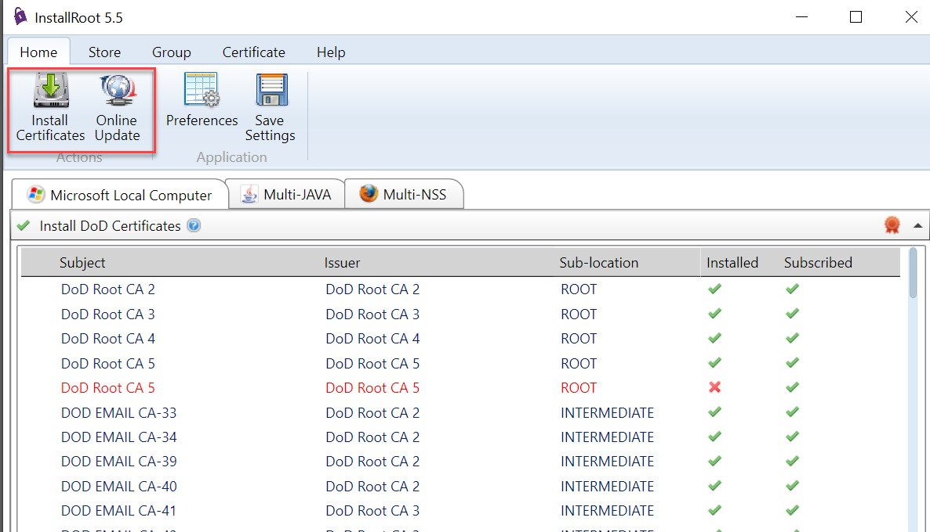

DoD Certificates Installation Guide for Mac OS

Install DoD Root Certificates
- Navigate to Tools and Configuration Files on the DoD Cyber Exchange (Public) site (https://public.cyber.mil/pki-pke/tools-configuration-files/). Note:

- Navigate to the second page of options and choose ‘PKI CA Certificate Bundles: PKCS#7 for DoD PKI Only – Version X.X’.
Note: The version number may change as the Defense Information Systems Agency (DISA) updates the certificate file. As of 30 December 2021 the current version is 5.9 (updated on 08 Aug 2021).

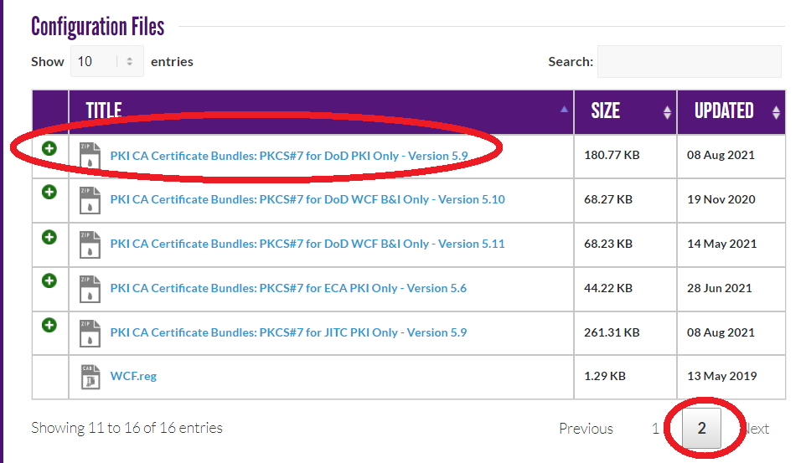
- Download and open the bundle. Eight total files will be available.

- Double-click all files that end with ‘.p7b’ and ‘.pem’.
Note: The ‘README.txt’ and the “Certificates_PKCS7_v5.9_DoD.sha256” are not certificate files.

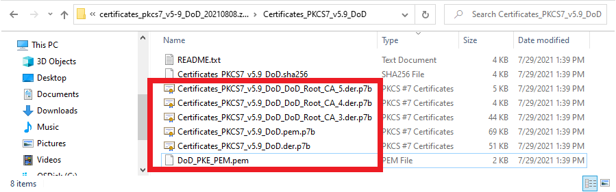

- Upon opening each file, your Keychain Access will open and populate the certificates.

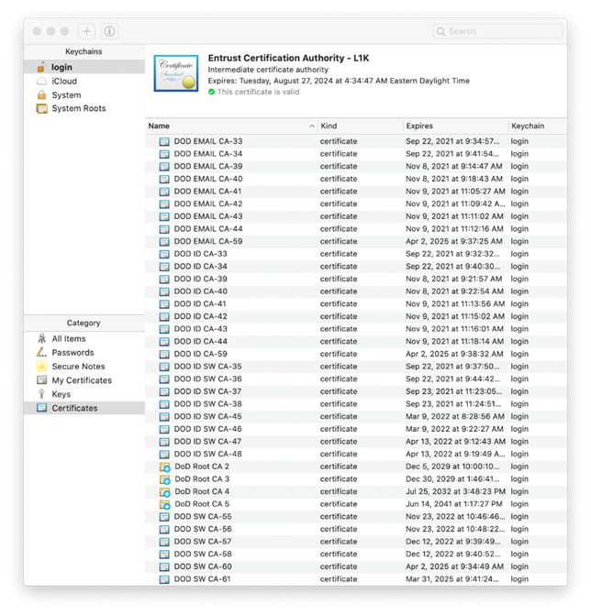

- Once all certificates have been added, double-click on ‘DoD Root CA 3’, ‘DoD Root CA 4’, and ‘DoD Root CA 5’ certificates. For each item, select the ‘Trust’ feature and change the default for 'When using this certificate' from 'Use System Defaults' to 'Always Trust'.

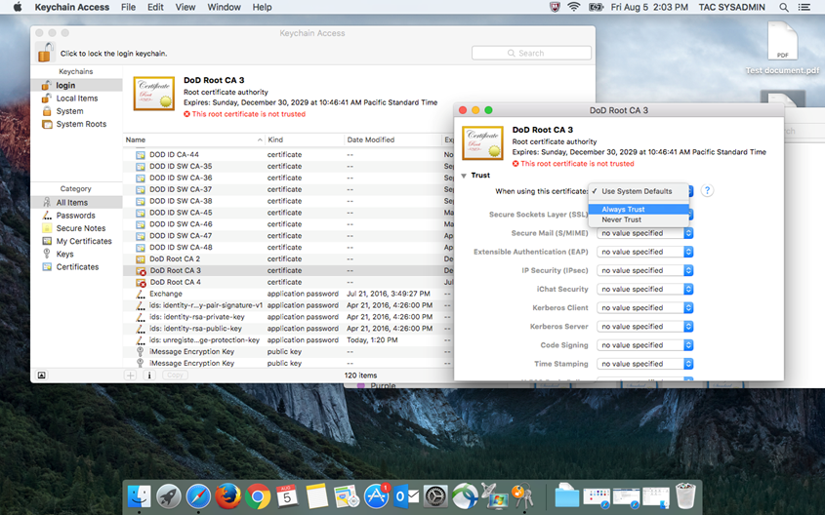

- Confirm your changes by entering an administrative password.

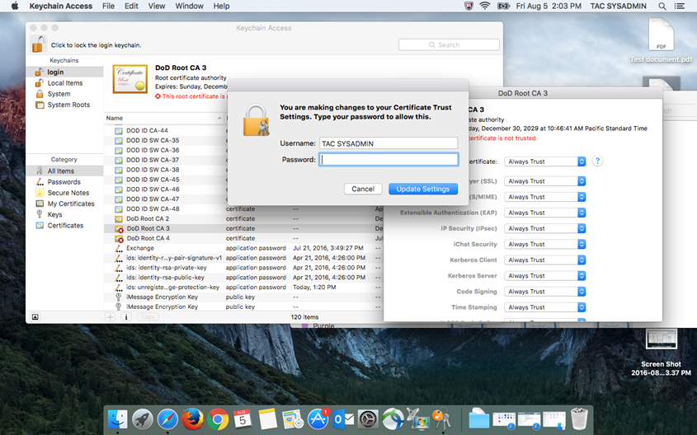

- Quit the Keychain Access utility.

Microsoft 365 (M365) Web-based Applications
The below step-by-step instructions will help users navigate to M365 web-based applications, including Outlook Web Access (OWA), Teams, Word, Excel, PowerPoint, OneNote, OneDrive, and SharePoint.

- Open a new browser session through Microsoft Edge (Windows), Safari (macOS), or Google Chrome (Windows/macOS). Enter https://portal.apps.mil into the URL field.

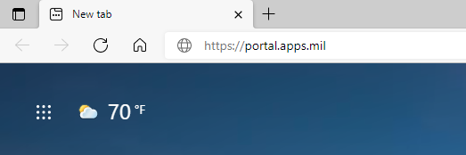

- Enter your dodiis.mil email address into the Windows logon screen and then select ‘Next’.

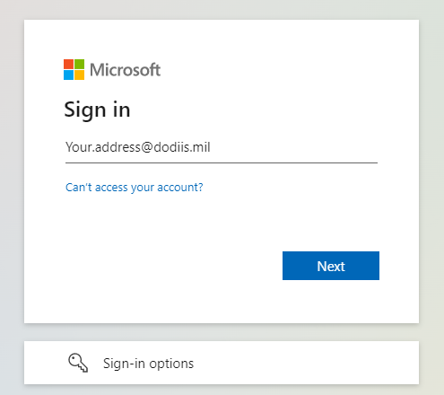

- Select ‘Sign in with a CAC’.

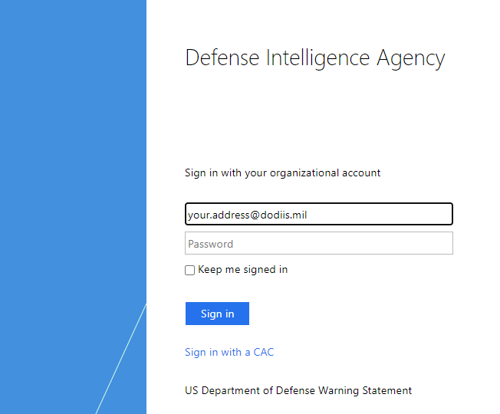

- Identify and select your PIV/Authentication certificate (16-digit certificate), then click ‘OK’. Enter your PIN and select ‘OK’.

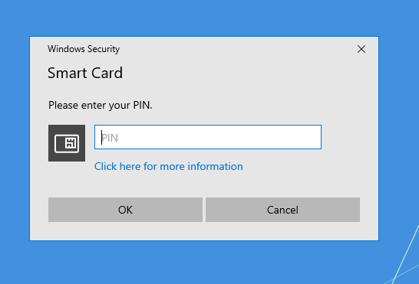

- The M365 home portal will open to its start page. From here, you can access M365 web-based applications, including Outlook and MS Teams.

